Theory Behind Measurement:
- Direct heat-flow calorimeter:
the instrument actively holds the sample at constant temperature.
It reports heat flow $\dot{Q }$(W) directly — often the electrical power supplied/removed by the thermostat/heater or a thermopile sensor reading.
Total heat Q over time interval [0, t₁];
$Q=\int_{0}^{t_{1}}{\dot{Qdt }}$ ; Here, $\dot{Q} in watt, t_{1} in Seconds and Q in joules$

- Indirect/ semi-adiabatic calorimeter:
You measure T(t) inside the vial and ambient T_{amb}(t).
The reaction heat flow is inferred from the temperature change and heat losses.
lumped heat capacity –
$$C\frac{dT}{dt}={\dot{q}}_{reaction}\left(t\right)-K_{l}\left(T\left(t\right)-T_{amb}\left(t\right)\right)$$
Where,
C = mc = effective capacity of sample (J/k)
K_{l} = heat-loss coefficient ( W/K)
${\dot{q}}_{reaction}$ = instantaneous heat flow from reaction (W)

Rearrange the above equation to get instantaneous heat flow,
$${\dot{q}}_{reaction}\left(t\right)=C\frac{dT}{dt}+K_{l}\left(T\left(t\right)-T_{amb}\left(t\right)\right)$$
By integrating, we will found total heat from time elapsing 0 to t₁:

${Q=\int_{0}^{t_{1}}{{\dot{q}}_{reaction}\left(t\right)dt}}_{}=C(T\left(t_{1}\right)-T_{0})+\int_{0}^{t_{1}}{K_{l}\left(T\left(t\right)-T_{amb}\left(t\right)\right)dt }$

Determination of C & K_{l} parameters from calibration Equation:
- Measurement of C — the heat capacity of the sample+vial system
Electrical calibration (recommended): Put a small heater (resistor) inside the vial, apply known constant electrical power (W)for time τ. Record temperature rise ΔT.

If losses are negligible during the pulse: $C≈\frac{Pτ}{ΔT}$
More accurately, apply a pulse and fit the full model (see below) to account for losses.
Mass × specific heat (approximate): $C≈m_{sample}c_{sample}+C_{vessel}.$ Use literature mode $c$ or measured values.
Measure $k_{l}$​ — heat-loss coefficient
- Cooling experiment: Heat the vial a few °C above ambient, then record T(t) as it cools naturally to ambient (no reaction).
For the lumped model:
$$\frac{dT}{dt}= -\frac{K_{l}}{C}(T-T_{amb} )$$
By Integrating, $\left(T\left(t\right)-T_{amb} \right)=\left(T_{0}-T_{amb}\right)e^{-\frac{k_{l}}{C}t}$.
Fit an exponential to the measured cooling curve to get $α=\frac{K_{l}}{C}$. Then,${ K}_{l}=αC$
Data processing

But, The heat Capacity, C, we have found is heat capacity of potable water & the vessel. However, We have already found the heat capacity of the vessel by our calibration experiment and now, we want to retrieve the heat capacity of Cement sample for conducting the experiment, $C_{cement}$ during calibration experiment.
Cement Paste show variable heat capacity during hydration. As a result, we have to develop a equation to address the variability of cement paste.

From the previous study relevant to the variability of heat capacity of cement paste during hydration could be utilized to calculate the generated heat by the above differential equation.

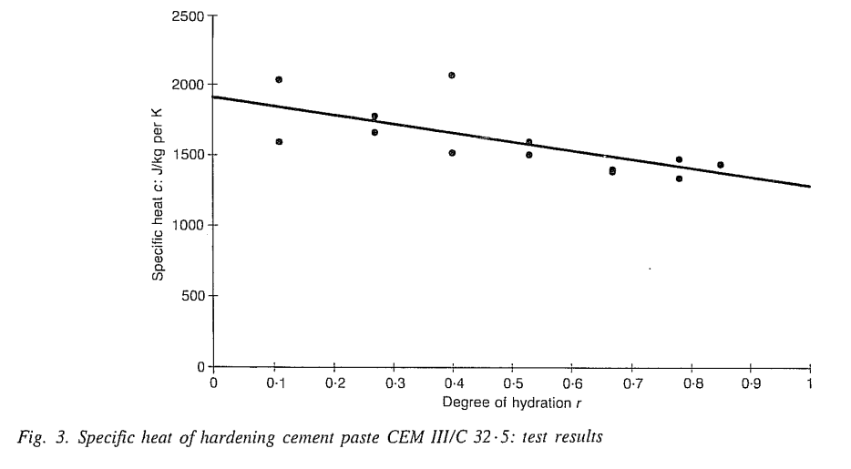
From the work done by De Schutter and Marwe , he have shown a relationship of specific heat of cement paste and the degree of hydration. For, CEM III/C 32.5 (slag rich cement ) & w/c ratio 0.5, the relation derived,
$C_{p}\left(r\right)=1300\left(1.5-0.5r\right)$ J/kg per kelvin
$or C_{p}\left(r\right)=1.3\left(1.5-0.5r\right)$ J/kg per kelvin
Here, we are using a w/c ratio of 0.4 and 0.5, our cement material is CEM II AM 42.5R. Basically, the heat capacity of cement decreases as degree of hydration increases resulting changes in microstructure.
Studies on hardening concrete show a linear reduction in specific heat capacity with advancing hydration.
CEM II A-M 42.5R might show a similar linear decline as degree of hydration increases from 0 to 1. This aligns with Portland systems due the similarity in formation of microstructure, though slag cements may have slightly lower final heat capacity due to denser microstructures. For RHC (pure Portland), the initial heat capacity might be comparable, but the drop occurs faster due to faster increase in degree of hydration. So, We are using the linear property found on previous study with a circumstantial modification.

$C_{p}\left(r\right)=1.205\left(1.5-0.5r\right)$ J/g per kelvin

Based on linear property, We may use the linear relationship as like
$$C_{p}\left(r\right)=C_{p}\left(0\right)+rk$$

Here, the ‘r’ indicates the ultimate degree of hydration, the constant ‘k’ depends on the type and ingredients of cement powder.

Here, The degree of hydration (r) for CEM II A-M 42.5 R cement is time-dependent and influenced by factors like water-to-cement ratio (w/c), curing temperature, and specific additions (e.g., slag, limestone, or pozzolan in the 6-20% range for A-class). Based on isothermal calorimetry data for similar cements of VIT MILAUER (e.g., CEM II A-M (S-V) 42.5 R at w/c=0.40 and 20°C), α at 7 days (168 hours) is approximately 0.68. The asymptotic (ultimate) degree of hydration is typically assumed to be 0.85, as long-term measurements are limited and hydration slows significantly after early stages.

Alternatively, the Mills formula for ultimate α in Portland-based systems yields ~0.70 for w/c ratio 0.405 : $r_{u}=\frac{1.031(\frac{w}{c})}{(0.194+\frac{w}{c})}$ . This is a conservative estimate, as blended cements like CEM II may achieve slightly higher effective α due to secondary reactions from additions, though the clinker fraction hydrates similarly to CEM I.

However, we may apply mills formula due to the flexibility of changes of w/c ratio in a considerable range.

The value of constant depends on the constituents of cement powder, the percentage of additives, slag and limestone.
From the work of De Schutter & Taerwe (1995) (Ref: Fig. 3) → For CEM III/C 32.5 (high slag, ~66–80 %): linear decrease from ≈ 1957 J/kg-K (α=0) to ≈ 1250 J/kg·K (α=1) yielding k ≈ 707 J/kg-k (very steep due to extensive water binding in slag hydration)
From the work of Bentz (2007) (Transient Plane Source measurements on hydrating Portland cement pastes, NIST CCRL proficiency sample ≈ Type I/CEM I) Linear decrease; fresh paste (α≈0, w/c ≈0.4–0.5) C_{p} ≈ 1830–1890 J/kg·K → fully hydrated C_{p}≈ 1300–1400 J/kg·K (saturated/sealed) → effective k ≈ 700–1100 J/kg·K (steeper in sealed/self-desiccating conditions).

Now, what will be the value of constant ‘k’ for the cement paste prepared by CEM II AM 42.5 R ?

‘k’ of our sample is significantly lower than the slag-rich CEM III/C value in your image because CEM II A-M has far less pozzolanic material. CEM II A-M contains slag/fly), k tends toward the lower value. If it contains near 20 %, it may approach 1100 J/kg-K.
For w/c ≈ 0.405 paste in a semi-adiabatic (partially sealed/self-desiccating) setup, the most representative value across thermal modeling literature for CEM II / low-blend Portland-composite 42.5 R cements is:
k ≈ 1100 J/kg-K

According to De Schutter G. et al. based prediction of thermal characteristics of hardening concrete; 1992 -
The degree of hydration is defined by r(t) of cementitious material defined as the fraction of cement that has already hydrated:
$r\left(t\right)=\frac{amount of cement that has reacted at time t}{total amount of time at t=0 }$

a practical method to estimate the degree of hydration is based on the exothermic character of the hydration process:
$$r\left(t\right)=\frac{Q\left(t\right)}{Q_{max}}$$
Where, Q(t) is the total heat developed at time t (in J/g ) and Q_{max} is the total heat development corresponding to complete hydration ( in J/g ).
The total heat Q(t) can be calculated as
$$Q\left(t\right)=\int_{0}^{t }{q\left(t\right)dt}$$
Where q(t) is the heat production (in J/g per h)
In ref. 2 a new hydration model is developed, yielding a heat production q depending on the actual degree of hydration r(t) and the actual temperature $θ\left(t\right)$
$$q\left(t\right)=q\left[r\left(t\right), θ\left(t\right)\right]$$

From the third consecutive equation above, We can establish following relationships:
$$\frac{dQ\left(t\right)}{dt}=q\left(t\right)=q[r\left(t\right), θ\left(t\right)]$$
Now, differentiating the second consecutive equation and the introduction of equation yield,
$$dr\left(t\right)=\frac{dQ(t)}{Q_{max}}=\frac{q[r\left(t\right), θ\left(t\right)]}{Q_{max}}dt$$
Hence, the value of r can be updated by substituting the above equation,
$$r\left(t+dt\right)=r\left(t\right)+dr\left(t\right) or$$
$$r\left(t+Δt\right)=r\left(t\right)+Δr$$

Steps to be followed for the experiment:
- At first, calibrate the insulator and measure the required constant for the differential equations of semi-adiabatic conditions.
- First, record the temperature with a fixed inside and outside of the sealed insulator by a High precision thermometer.
- Store the data in a excel file and convert time, unit other necessary data for analysis
- To analyze the differential equation, To address the variable heat capacity of cement paste which is dependent on the degree of hydration. We have used previous findings and study .
- We have used MATLAB software to plot the time versus generation rate and the nature of the paste compared to OPC.
- We have the Xrd data of our cement paste, From which we could find percentage mineralogical ingredients from which, we will simulate the hydration heat rate vs time from a software called VCCTL !

